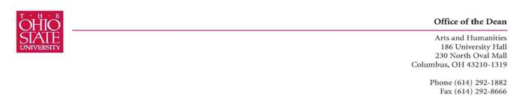

October 13, 2009

Dear Dick and Stafford,

The Committee on Curriculum and Instruction’s Arts and Humanities Subcommittee met on October 6th and discussed Hebrew 245, “Israeli Film and Society.” We unanimously approved it for the Visual and Performing Arts category.

We did note that we need Naomi to remove the “D-“ on the grading scale since this grading option does not exist at OSU. Once Naomi has a chance to delete the “D-“ please send this to me and we will move it forward to OAA. May I say that it was a pleasure working with Naomi on the syllabus. This is a prime example of how a course can be created over the summer, given approval at unit and Arts and Humanities level, and then approved for GEC in a relatively short period of time (8 weeks). Please thank her for her hard work.

Thank you for your commitment to Undergraduate education at OSU,
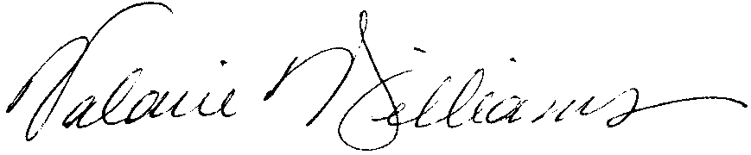
Valarie Williams
Chair, CCI Subcommittee B
Professor of Dance
Associate Dean, Arts and Humanities

